**UT_IT Test Report**

UT_01- Add Supplier

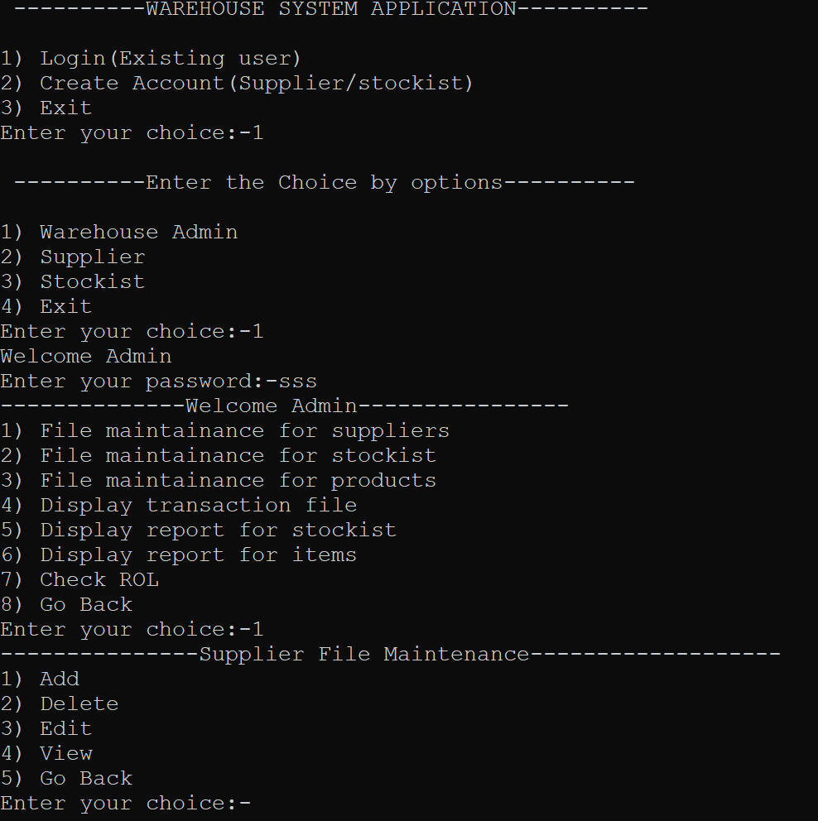

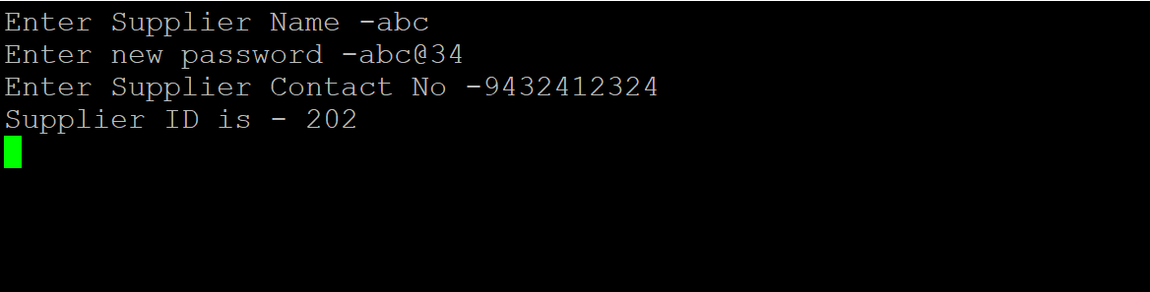

UT_02- Add Stockist

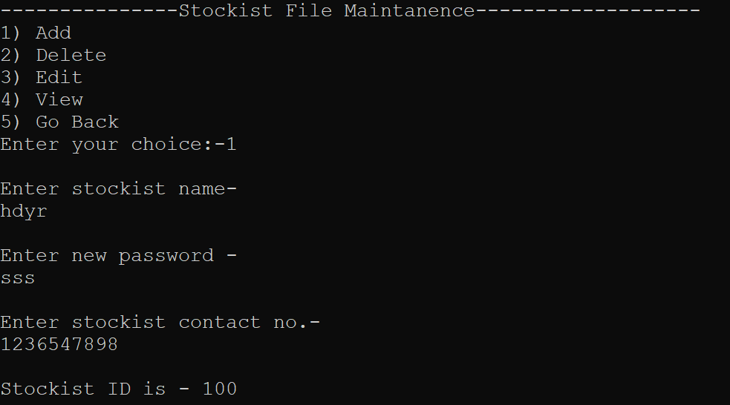

UT_03 - View Supplier

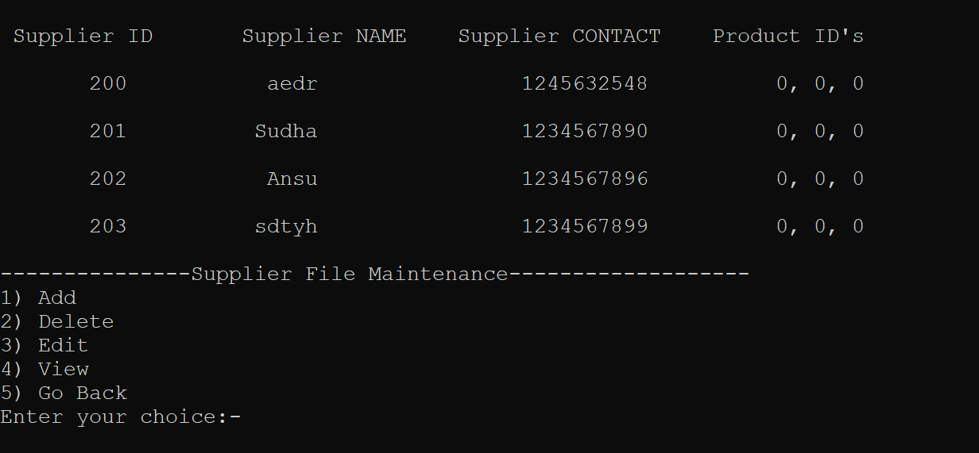

UT_04 - View Stockist

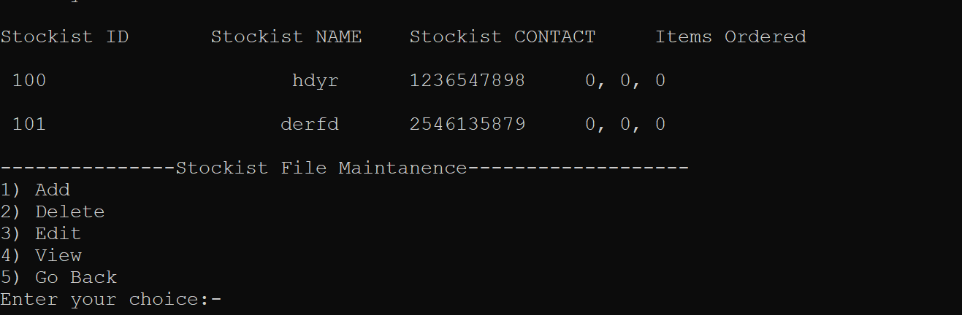

UT_05 - Add Product

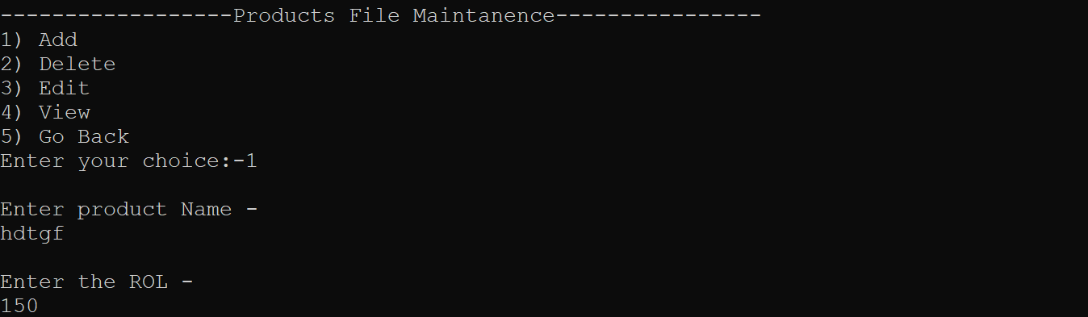

UT_06 - View Product

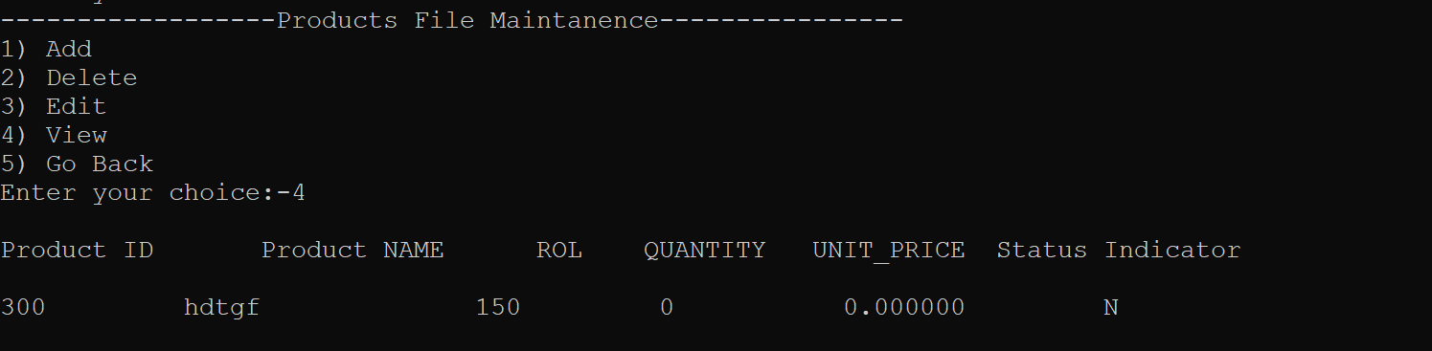

UT_07 - Create new account for supplier

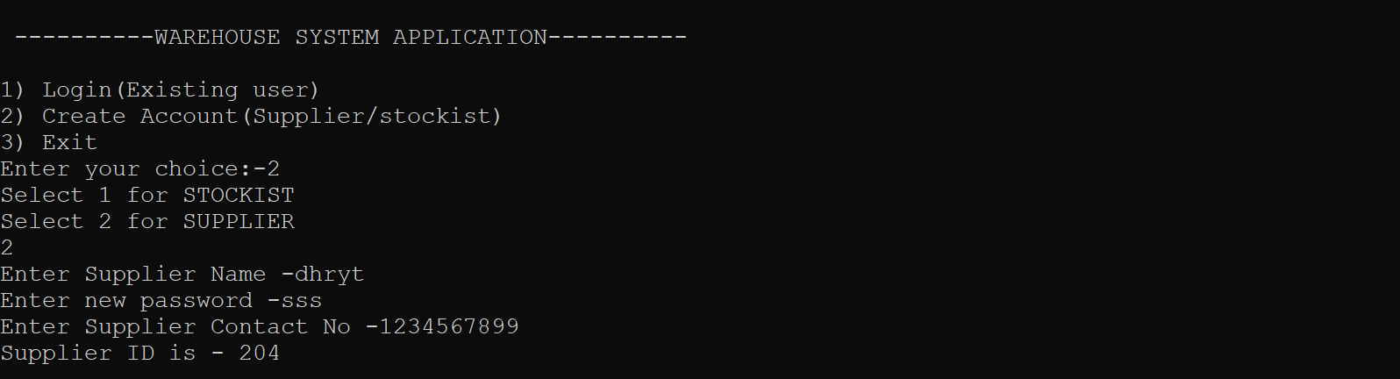

UT_08 - Create new account for stockist

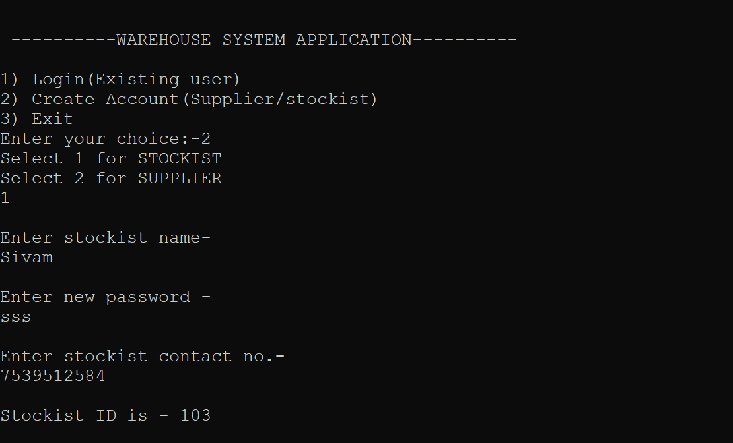

UT_09 - Edit Supplier

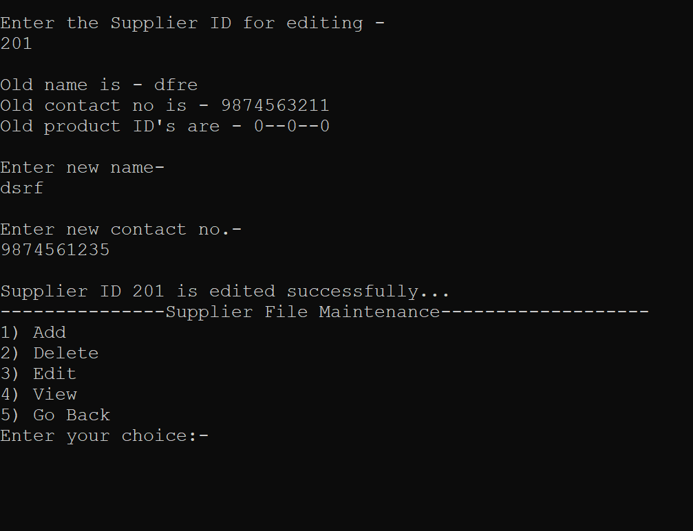

UT_10 - Edit Stockist



UT_11 - Edit Product

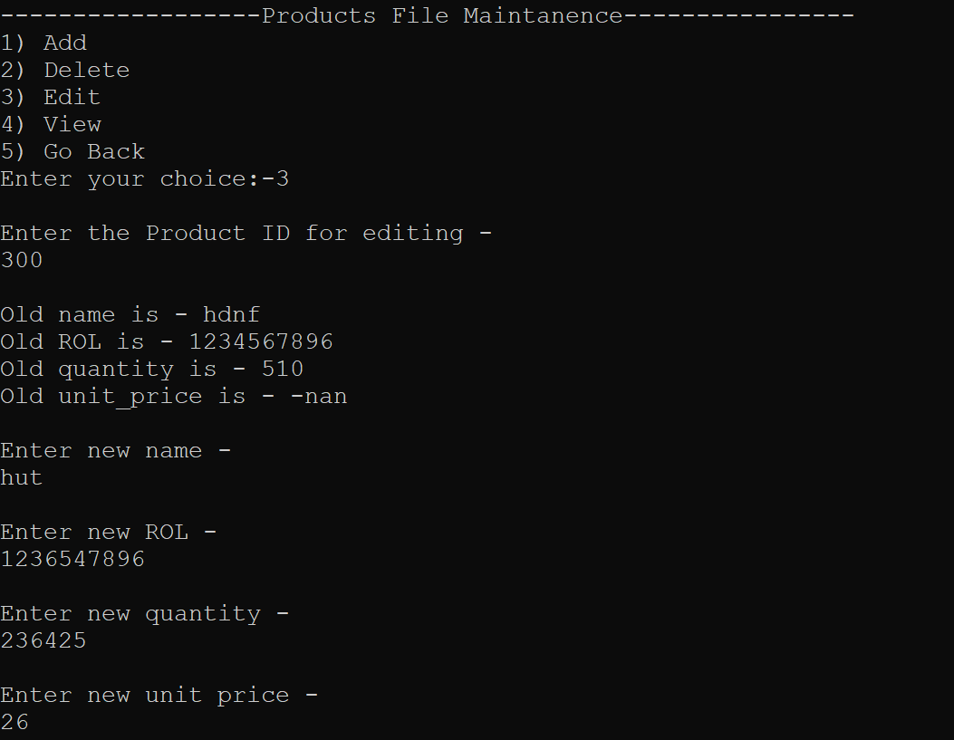

IT_01 - Login For Admin

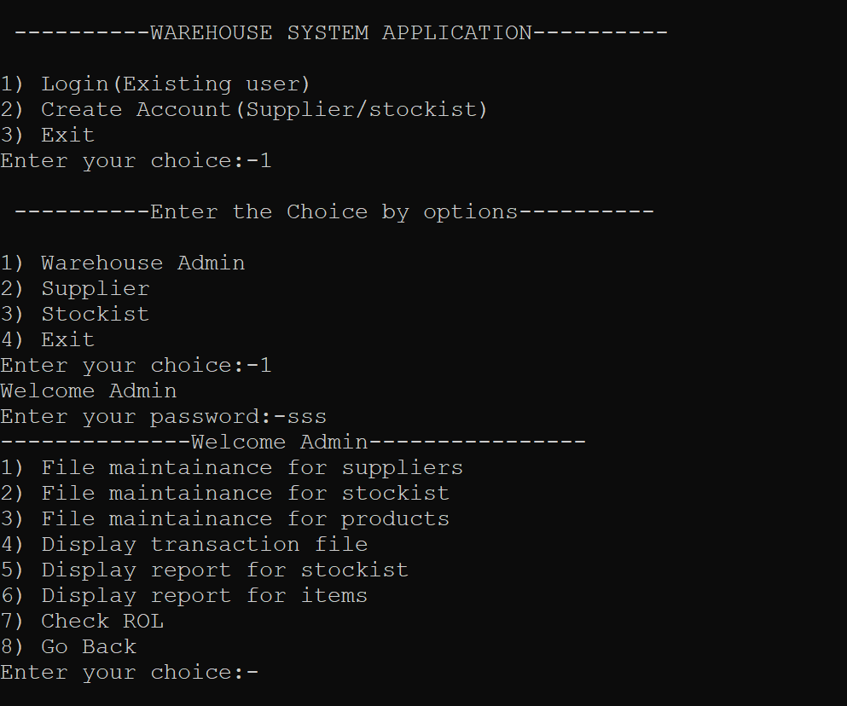

IT_02 - Login for Supplier

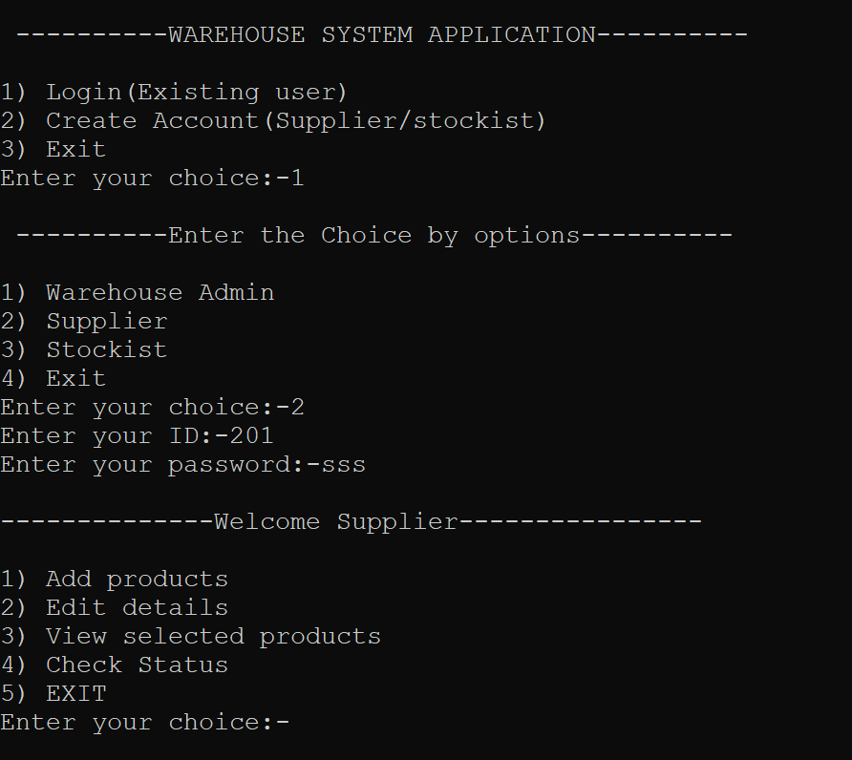

IT_03 - Login for Stockist

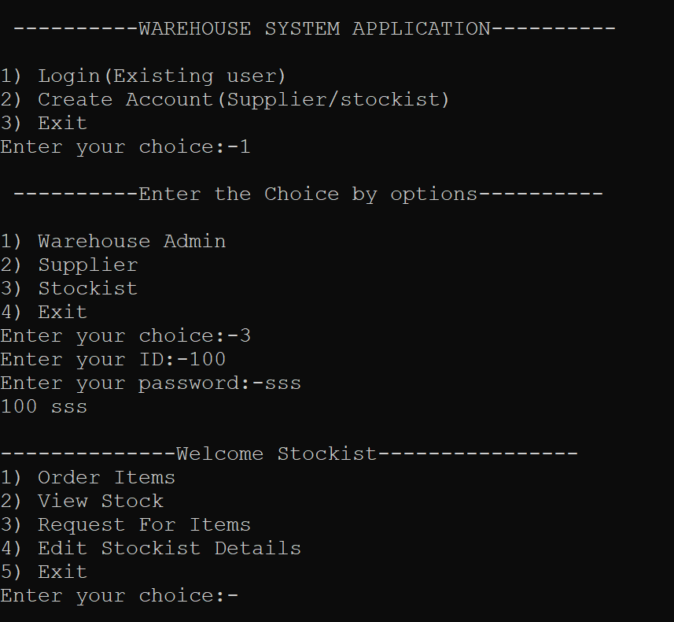

IT_04 - Request for Items

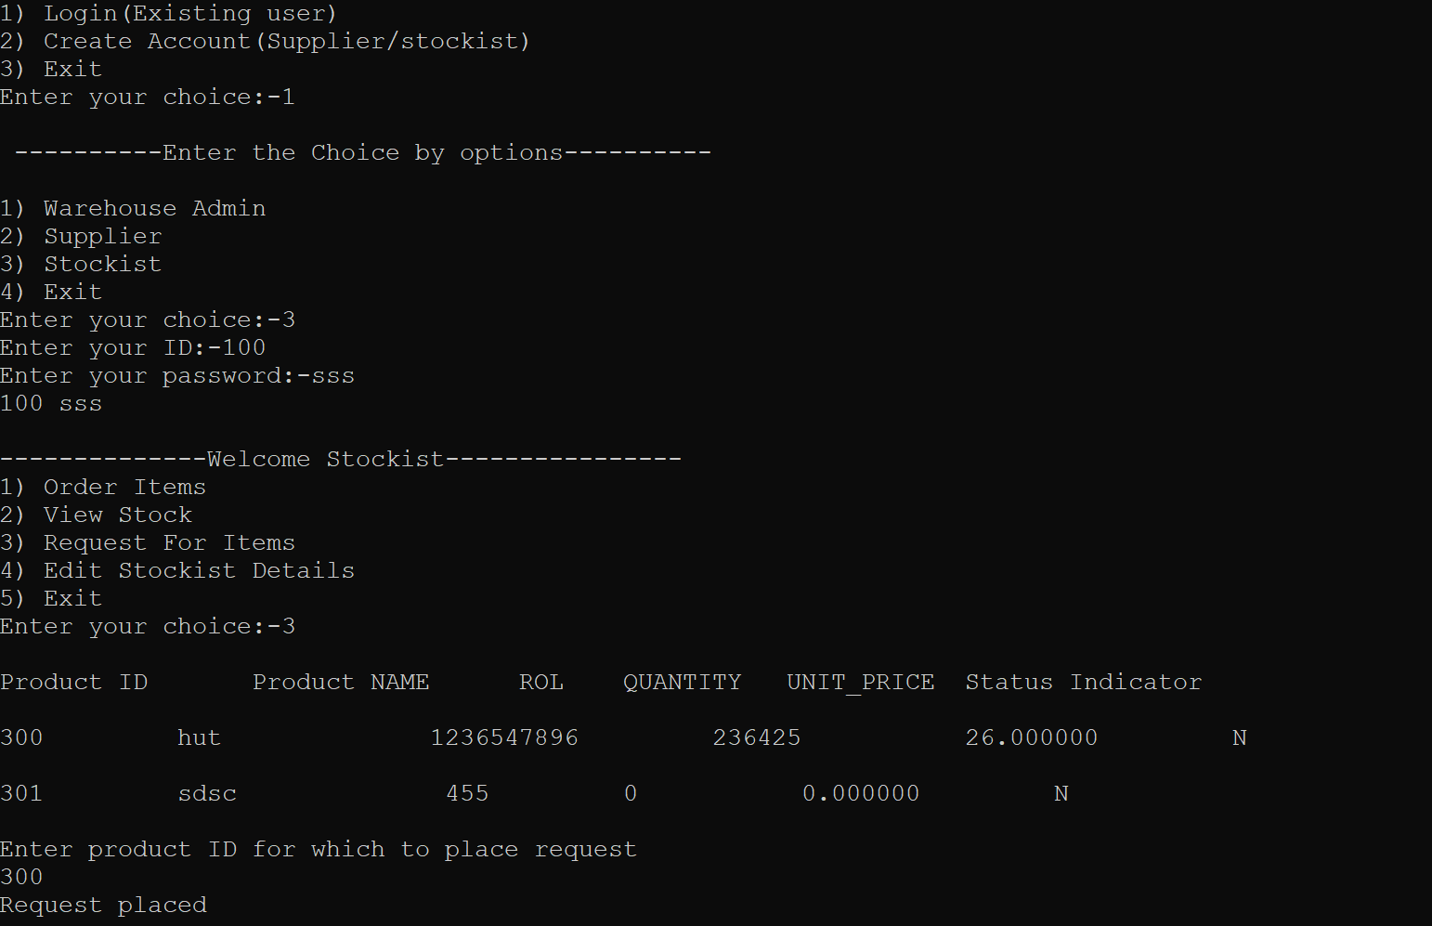

IT_05 - Stockist request for items to restock

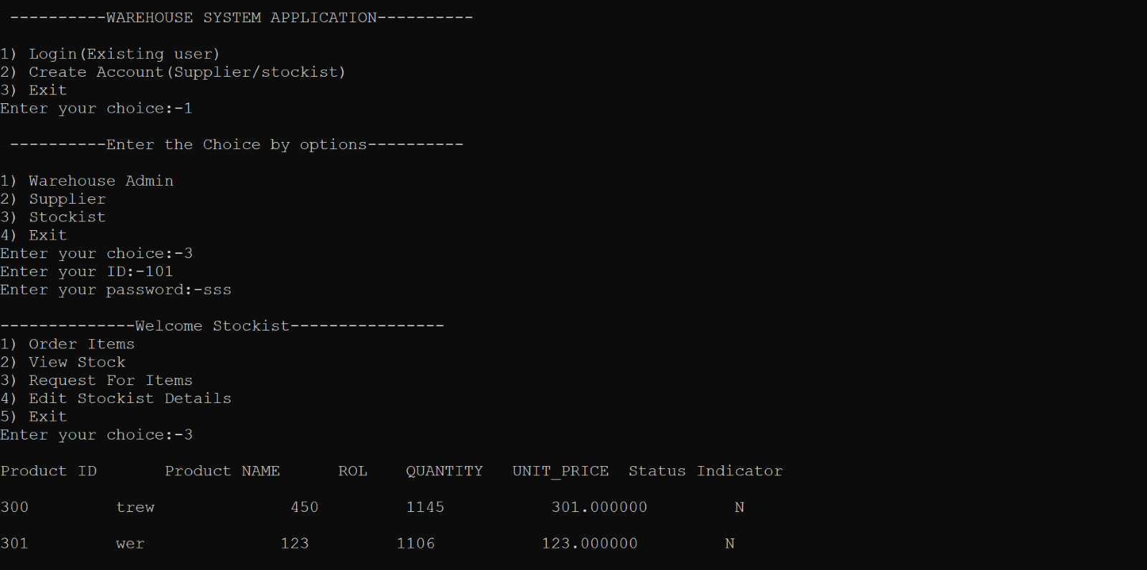

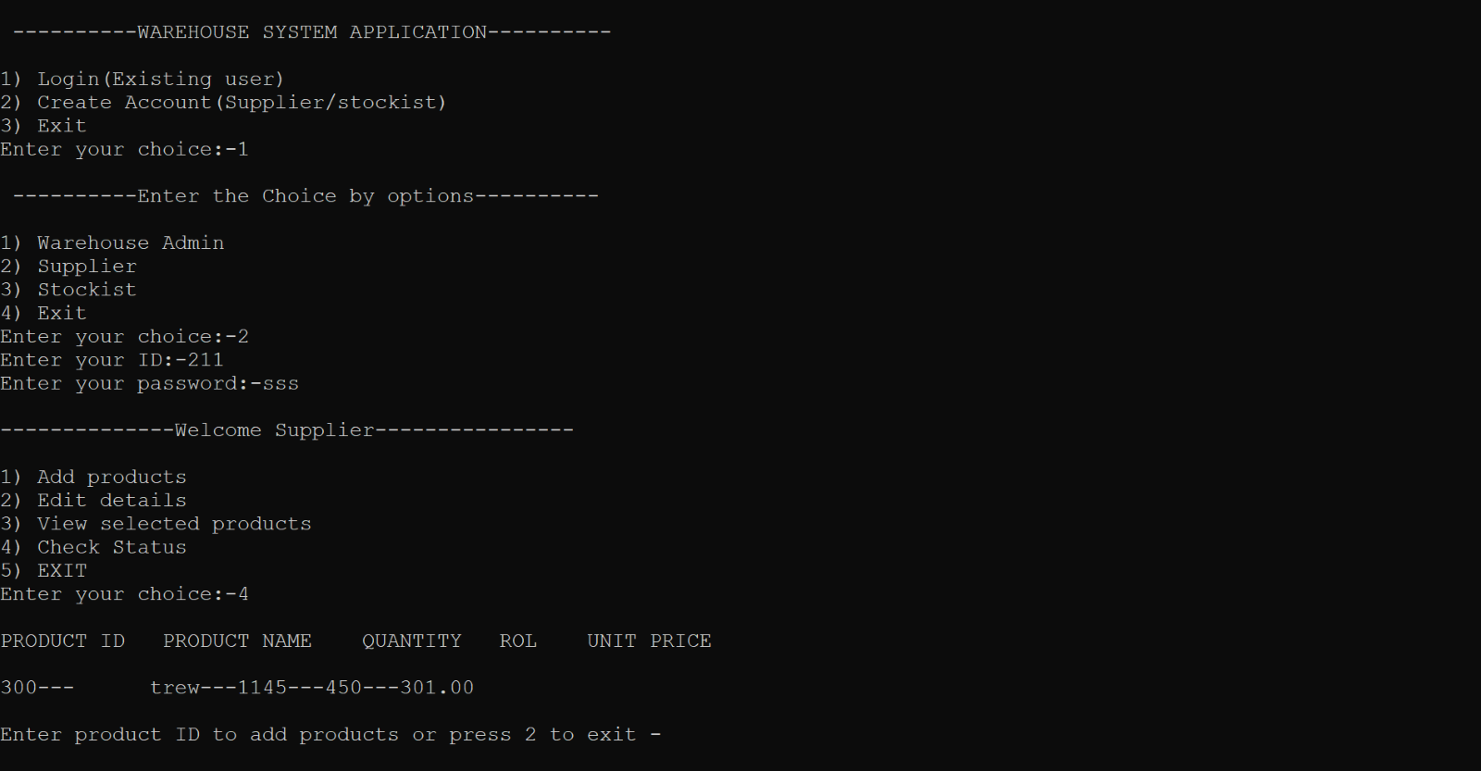

IT_06 -Stockist Transcation File report

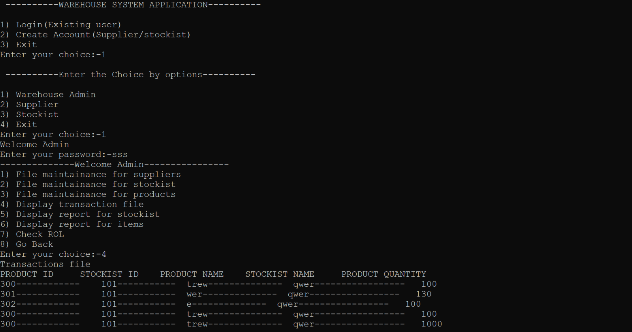

IT_07 - Stockist ID created by Admin.

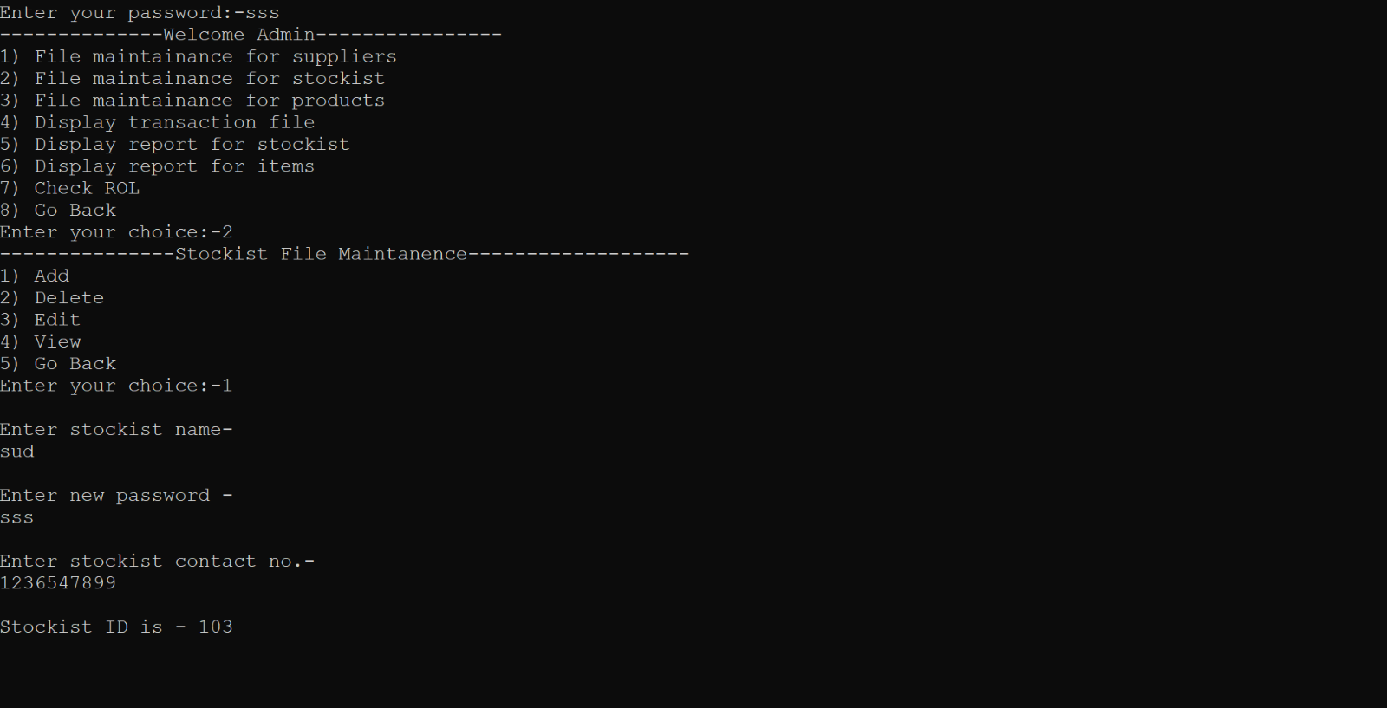

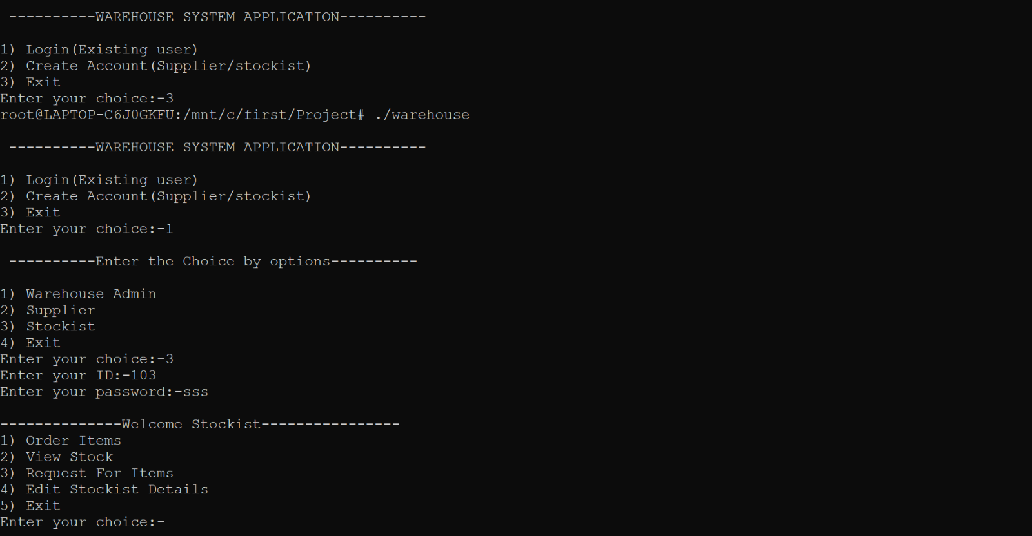

IT_08 - Supplier (Admin) to Supplier login

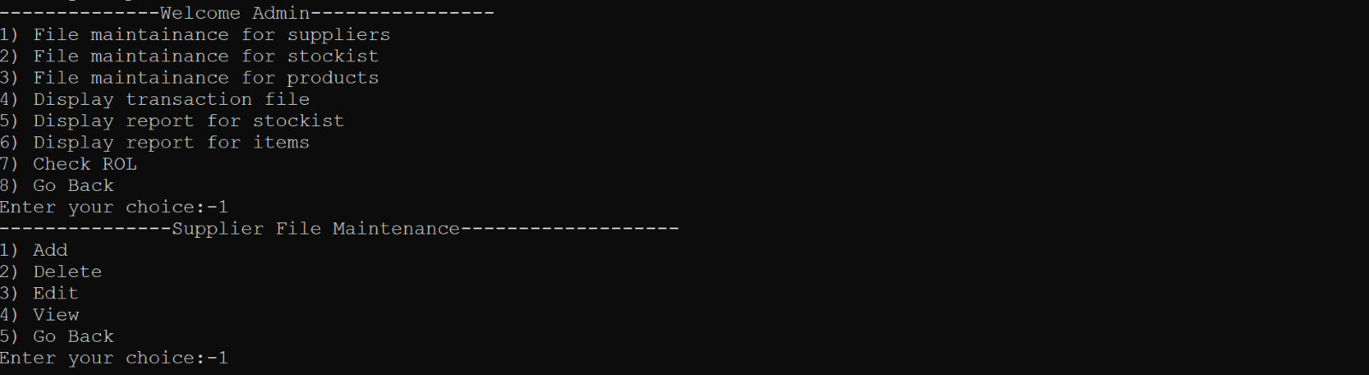



IT_09 - Adding product and supplied by supplier

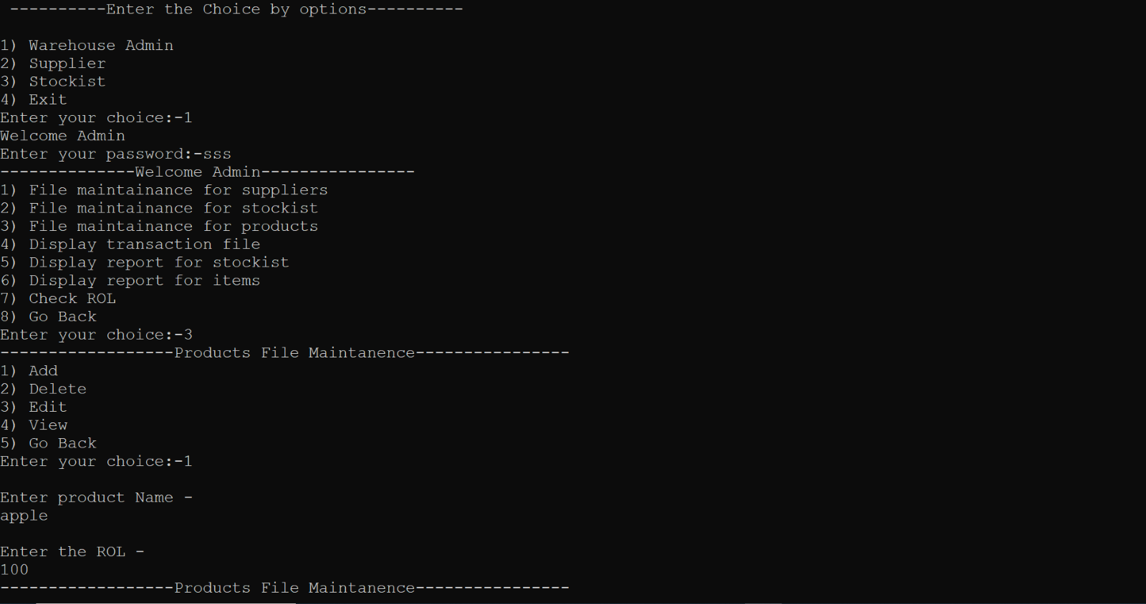

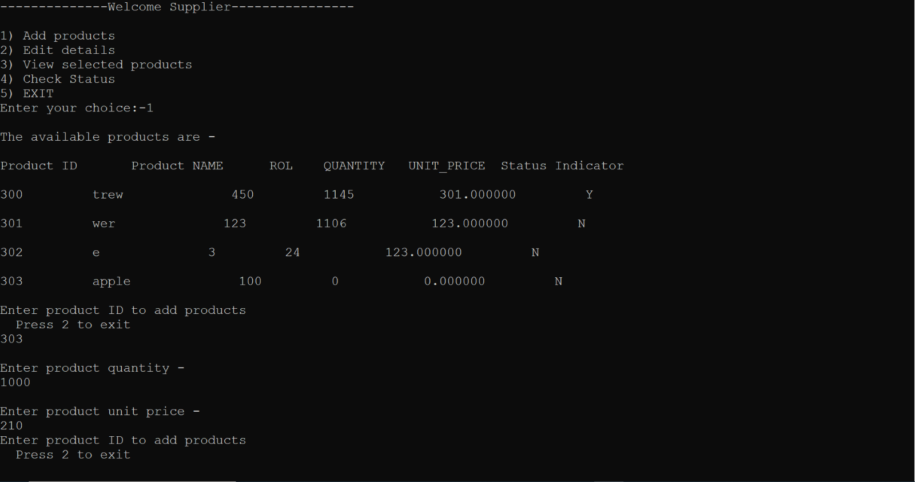

IT_10 - View supplied product by supplier id

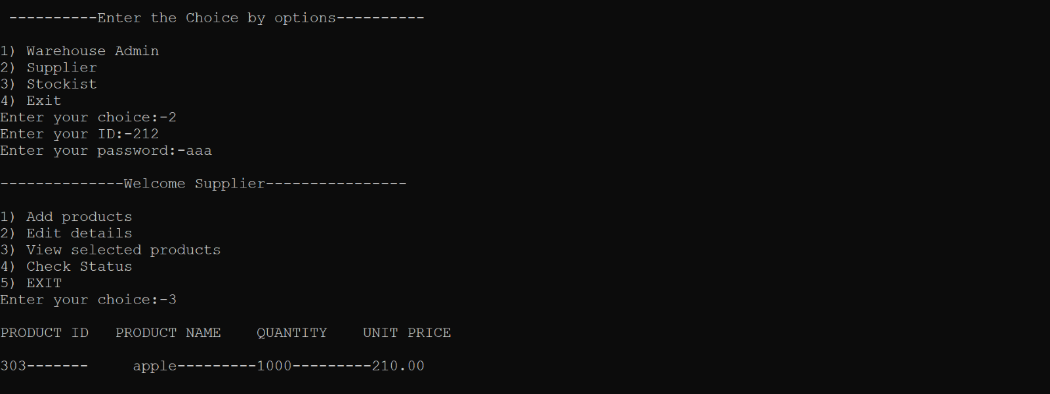

IT_11 -Item order by stockiest id and view by supplier id

